Physics 30 Lesson 10

Dispersion, Scattering, Colour, Polarisation

Dispersion
When light rays are refracted, the change in direction depends on the difference in speed between the two mediums.
Medium 1
Medium 2
n₂ > n₁

v₂ < v₁

λ₂ < λ₁

frequency remains constant

However!! The index of refraction (n) depends, to a small degree, on the wavelength of the light. Normally this effect is so small that it does not result in a noticeable difference between different wavelengths (i.e. colours) of light, but for glass triangular prisms, the difference in the index of refraction for different colours of light results in a separation of the white light into its spectrum of colours. This separation of light into its colours is called dispersion. (Refer to Pearson pages 675 to 676.)
red
orange
yellow
green
blue
violet

Rainbows are also a result of dispersion. If the sun is shining and there are water droplets in the air, either due to rain or mist from a waterfall or sprinkler, rainbows can form. As shown in the diagram below, different wavelengths of light are refracted by different amounts by the water droplets. In this way, the different colours are separated resulting in a rainbow. Note that where an observer sees the rainbow depends on the position of the observer. If the observer moves, the rainbow moves. Thus, you can never find the pot of gold that is rumoured to exist at the end of a rainbow.

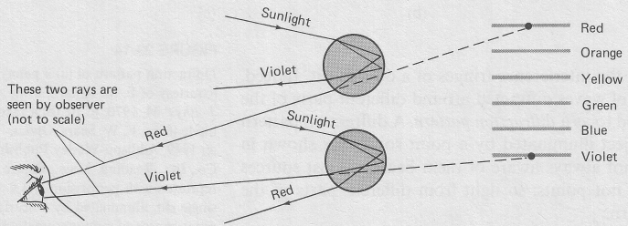
The dispersion of light demonstrates that white light is actually a combination of all the colours of visible light combined together. Light is a spectrum of wavelengths and frequencies. But visible light is only a small part of the light spectrum. As you will learn in Lesson 24, radio, infra red, ultra violet and x-rays are all light waves – they have different wavelengths and frequencies, but their speeds are all the same: 3.00 x 10⁸ m/s.

Light Spectrum

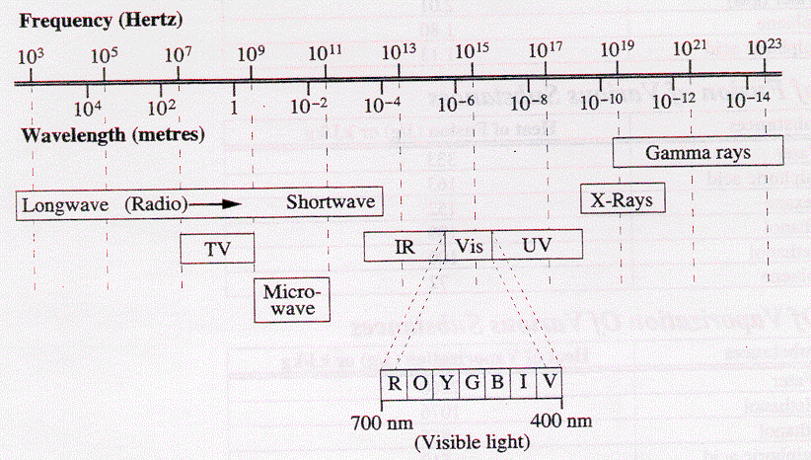

Scattering – Why is the sky blue?
To understand why the sky is blue, we need to first understand how an object becomes visible to us. For example, if a white light source is turned on, the light may travel right past us without us seeing it.

focused light source
white light

In order to see the light, some of the light must reflect off of particles like dust and lint in the air into our eyes. This is the basis of scattering. When light hits particles or molecules in the atmosphere, it is scattered in all directions by the particle or molecule. Some of the scattered light goes into our eyes, while the unscattered light continues without our knowing it was ever there.

unscattered light

scattered light

The scattering of light in the Earth’s atmosphere is proportional to the fourth power of the frequency (f⁴). Therefore, the higher the frequency, the more the light will be scattered. Blue light and violet light are scattered much more than red or orange, so the sky looks blue. The entire sky appears blue because the blue light is being scattered in all directions at the same time. Some blue light is scattered toward our eyes from every direction in the sky.

At sunset, the sun’s rays have passed through a maximum length of atmosphere where much of the blue light is scattered out. Thus the light that reaches the surface of the earth and scatters off of dust particles in the sky is lacking in blue coloured light. The remaining light is scattered by the larger particles of dust in the lower atmosphere, making the sunset appear reddish.
scattered blue light
Sun

red remains and is scattered to where we are

The dependence of scattering on f⁴ is valid only if the scattering objects are much smaller than the wavelength of the light. This is valid for oxygen and nitrogen molecules. Thus if the atmosphere did not contain oxygen or nitrogen, the sky would appear quite different. Clouds, however, contain water droplets or crystals that are much larger – they scatter all frequencies of light uniformly. Hence clouds appear white.

Colour
As we saw with dispersion, white light is composed of different colours mixed together. Black is the absence of light.

Subtraction Theory of Colour
The subtraction theory of colour attempts to explain the way that objects appear. When white light is incident on an object, the object will absorb certain colours and will reflect the remainder. For example, if white light is incident on a red object, blue and green are absorbed and red is reflected.

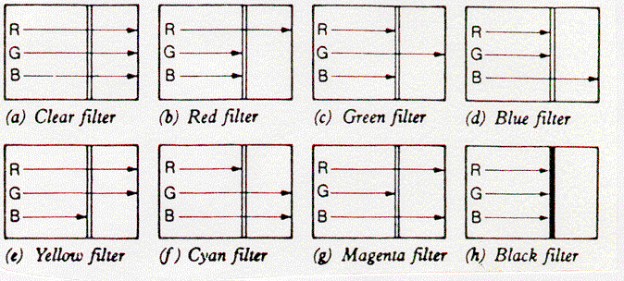
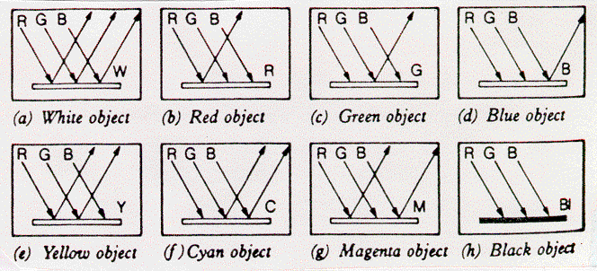

Addition Theory of Colour
The addition theory of light is that if different colours of light are combined, new colours will be formed. This is easily demonstrated using a colour light box.
blue + green = cyan
blue
red
red + green + blue = white
blue + red = magenta

green
red + green = yellow

This is also the way that our eyes see colours. Specialised cells (cones) in our eyes are sensitive to colour. There are three types of cones – blue, green and red – which allow us to see all colours since every colour is a combination of these three primary colours.

Polarisation
When light travels through space it vibrates in all planes. However, when light is passed through a polarising filter, the filter allows light waves through that are polarised in one plane. (Refer to Pearson pages 695 and 696.) In other words, the only light that passes through a polarising filter is the light that was vibrating in the same plane as the polarising filter.

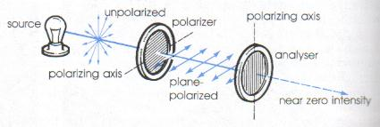

In the diagram above, unpolarised light passes through a polarising filter that is oriented to let horizontally polarised light to pass through. Of course if the filter were rotated it would allow different planes of light to pass through. If the horizontally polarised light next falls on a second filter that polarises light in the vertical plane, the light energy is almost completely absorbed. This occurs whenever the axes of the polarising filters are at right angles to each other. When the axes of the two filters are parallel, the light polarised by the first filter passes through the second filter without further absorption.
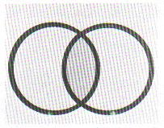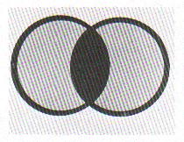
When polarising filter axis are parallel, light passes through.
When polarising filter axis are perpendicular, no light passes through.

Could these results be explained by longitudinal waves? If light travelled as a longitudinal wave, the vibrations would vibrate in only one direction, namely, the direction in which the wave was travelling. Such a wave would pass through a pair of polarising filters unaffected. In other words, a longitudinal wave cannot be polarised. Based on the polarisation evidence, we may conclude that light behaves like a transverse wave, not a longitudinal wave.

Polarisation Activity
Carry out the following investigations with the polarisation kit provided.

1. Hold one of the polarising disks up to a light and observe the effect as you rotate the disk through 360º. Now hold both disks to the light. Slowly rotate one of the disks through 360º. Note the positions of the axes on the disk rims when maximum and minimum light is transmitted. Explain, using a description and a diagram, the observed effects.

2. Place a calcite crystal over the words in the box below.
Physics
is
Phun

Notice the images produced and their apparent brightness relative to looking at the print without the crystal. Draw what you see. Place a single polarising disk over the crystal and rotate the disk through 360 degrees. Describe what happens.
Explain, using a description and a diagram, the observed effects.

3. Rotate one of the polarised filters over a wristwatch or calculator with a liquid crystal display. Record your observations. Explain why the LCD changed in appearance as the polarised filter was rotated.

4. Look around the classroom for any horizontal surface (such as the floor or a counter top) where you can see the glare of reflected light. Look at the glare with a polarised filter and then rotate the filter. Record your observations.
How would you use polarised sunglasses to eliminate or minimise the effects of glare from a road? Explain.

5. Observe the mica crystal disc. Place a polarising disk over it. Hold it toward a light source and rotate the disk. What happens? Now sandwich the mica disk between two polarising filters. Rotate one of the polarising disks. What happens?

6. Repeat step 5 substituting the benzoic acid crystal disk for the mica.

Hand-in assignment
1. Sunlight is made up of most of the colours of the spectrum. Although it is refracted by our atmosphere it is not dispersed into its colours as it travels through air. What does this tell you about the relative speeds of the various colours/wavelengths of the spectrum through air?

2. What observation indicates that diamond has slightly different refractive indices for each of the colours of the spectrum?

3. Considering the relationship between particle size and the scattering of light, is it better to use red light or blue light when photographing a tiny object through a microscope when you want to obtain maximum definition? Explain.

4. Why are you more comfortable on a hot sunny day in light-coloured clothes than in dark clothes?

5. What is the physical difference between red and orange light?

6. A performer wears blue clothes on stage. How could you use spotlights to make them appear black? Is it possible to make them appear red? Explain.

7. When white light passes through a flat piece of window glass, it is not dispersed into its colour spectrum. Why not?

8. An object appears green in white light. What colour will it appear to be if it is illuminated by (a) magenta light, (b) cyan light, and (c) pure blue light?

9. Cats do not see in colour, only black, white and grey. How do cat’s eyes differ from human eyes?

10. Why do objects seen in moonlight appear so colourless?

